**FEE MANAGEMENT SYSTEM PROJECT**

**Submitted by:**

Sameeksha Pande

**Contact No.**

+971-524804614

**Email ID:**

Sameekshapande@gmail.com

Table of Content

1. About the Project 3

2. Application Modules 3

1.1 Grading Module: 3

1.2 Grade Sheet Previous Year Module: 5

1.3 Enrolment Module: 5

1.4 Payment Module: 6

1.5 Payment Receipt Module: 7

1.6 Eureka Registry: 7

3. How to Access the Application 7

# About the Project

A Fee Management System is developed to digitally handle the school fees and streamline the fee collection and structuring. This system records the fee calculations per grade, previous fee payment details, student enrolment, payment and receipt management.

Through this fees management system, one can easily maintain the user-defined fee structure and range. The automatic receipt generation increases the reliability of the system. The system can accept the receipt of the fees with a few clicks.

# Application Modules

The application has six modules. The below diagram showcases the modules used in fee management system:

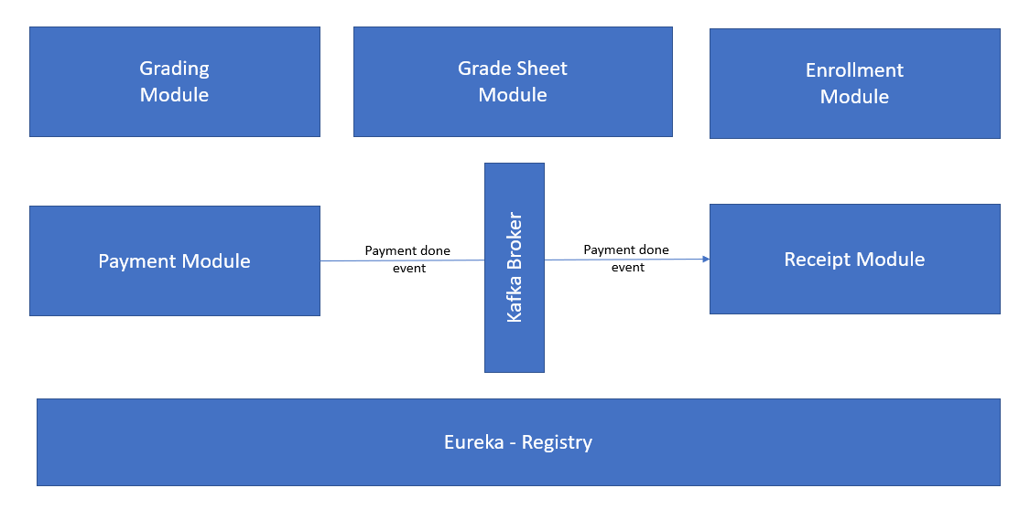

## Grading Module:

This module is used to capture the baseline information for fee management. This module will be used by Admin role. The admins has to enter the below information before initiating the enrollment & admission process. The information covers –

* Grade
* Fee
* No. of Seats
* Due Date

Add Grades: The admin has to use the URL to enter the grades, fees and no. of seats (capacity). Below are the details:

|  |  |
| --- | --- |
| URL: <http://localhost:9091/gradeservice/createGrade> | |
| Sample Request | Sample Response |
| {      "grade": "6",      "fees": 1000,      "capacity": 50,      "dueDate" : "02/02/2023"   } | {      "grade": 6,      "fees": 1000,      "capacity": 50,      "dueDate": "02/02/2023",      "id": 65  } |

**Get All Grades:** We can get all the grades configured in the system. Below is the sample.

|  |
| --- |
| URL: <http://localhost:9091/gradeservice/grades> |
| Sample Response |
|  |

Get the grades by grade ID:

|  |
| --- |
| URL: [http://localhost:9091/gradeservice/grades?id="1](http://localhost:9091/gradeservice/grades?id=%221)" |

## Grade Sheet Previous Year Module:

This will have data related to student those are passed in previous year and are eligible to take admission in next class.

|  |  |
| --- | --- |
| URL: | |
| Sample Request | Sample Response |
|  |  |

## Enrolment Module:

Students (existing as well as new) will be enrolled & payment will be handled.

Create Student: Student will get enrolled in school with status initiate.

|  |  |
| --- | --- |
| URL: <http://localhost:9090/enrollmentservice/enrollStudent> | |
| Sample Request | Sample Response |
| {  "studentName":"vedanti",  "grade":"6",  "mobileNumber":"524804614",  "schoolName":"SVN"  } | {      "studentId": 353,      "studentName": "vedanti",      "grade": 6,      "mobileNumber": "524804614",      "schoolName": "SVN",      "enrollmentStatus": "Initiated",      "admissionDate": **null**  } |

Get All Student: Get all students who are enrolled with their status.

|  |
| --- |
| URL: : <http://localhost:9090/enrollmentservice/getAllStudents> |
| Sample Response |
|  |

Update Student: Update student name or phone number in the database by student.

|  |  |
| --- | --- |
| URL: <http://localhost:9090/enrollmentservice/enrollStudent?id=97> | |
| Sample Request | Sample Response |
| {      "studentId": 97,      "studentName": "sameeksha Pande",      "grade": 1,      "mobileNumber": "524804614",      "schoolName": "SVN"  } | {      "studentId": 355,      "studentName": "sameeksha Pande",      "grade": 1,      "mobileNumber": "524804614",      "schoolName": "SVN",      "enrollmentStatus": "Initiated",      "admissionDate": “02/02/2023”  } |

Fee Payment: We have exposed API for fee payment.

|  |  |
| --- | --- |
| URL: <http://localhost:9090/enrollmentservice/payNow> | |
| Sample Request | Sample Response |
| {  "studentId": 353,  "studentName": "vedanti",  "grade":6,  "cardNumber":"1111111111111111",  "expiry":"11/25",  "cvv":"123",  "feeAamountPaid":1000  } | {      "paymentStatus": "Success",      "sendMessage": "Payment is Success"  } |

Note: Kindly Use same card No. as configured this card data as dummy success data.

Existing Student Enrolment:

|  |  |
| --- | --- |
| URL: <http://localhost:9090/enrollmentservice/enrollExistingStudent> | |
| Sample Request | Sample Response |
| {  "studentId": 999,      "studentName": "utkarsh kasar",  "grade":2,  "mobileNumber":"524804614",  "schoolName":"SVN"  } | {      "studentId": 386,      "studentName": "utkarsh kasar",      "grade": 2,      "mobileNumber": "524804614",      "schoolName": "SVN",      "enrollmentStatus": **null**,      "admissionDate": **null**  } |

## Payment Module:

Payment will go to 3rd party application (Payment Integration) and success/failure payment response will get send to upstream application. After success response from 3rd party application payment receipt response will be stored in message broker.

For demo purpose, this application is not integrated with payment gateway & dummy card numbers are used for proof of concept purpose.

|  |  |
| --- | --- |
| URL: | |
| Sample Request |  |
| {  "studentId":257,  "grade":1,  "cardNumber":"1111111111111111",  "expiry":"11/25",  "cvv":"123",  "feeAamountPaid":1  } |  |

## Payment Receipt Module:

This module is used to auto generate the receipt after payment module. Below is the sample response.

|  |
| --- |
| Sample Response |
| Sample Reciept response will be there in logs |

## Eureka Registry:

All the services will be deployed in Eureka Registry. Eureka Server holds the information about all the above applications. Every Micro service will register into the Eureka server and Eureka server knows all the services running on each port and IP address.

## 

# How to Access the Application

The application is uploaded on the GitHub and is accessible on below URL:

|  |
| --- |
| URL: <https://github.com/sameekshapande/FeeManagementSystem> |
|  |